Lesson 3 Demo 1: Create a Docker Image

This section will guide you to:

* Create a Docker image using the Dockerfile

**Step 1**: Create the Dockerfile

* Create a directory

*mkdir demo*

*cd demo*

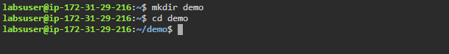

* Create the Dockerfile

*vi Dockerfile*



* Add the following code to the Dockerfile

*FROM ubuntu*

*RUN apt-get update*

*RUN apt-get install -y nginx*

*COPY index.nginx-debian.html /var/www/html*

*CMD nginx -g 'daemon off;'*

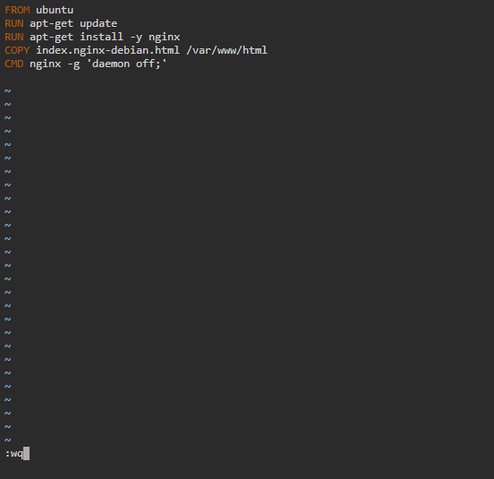

**Note:** After writing the above code in the *Dockerfile*, press **ESC** button and enter **:wq** to save the file and exit the editor.

* Create another file in the same directory

*vi index.nginx-debian.html*



* Add the following welcome message to the index file

*WELCOME TO NGINX.*

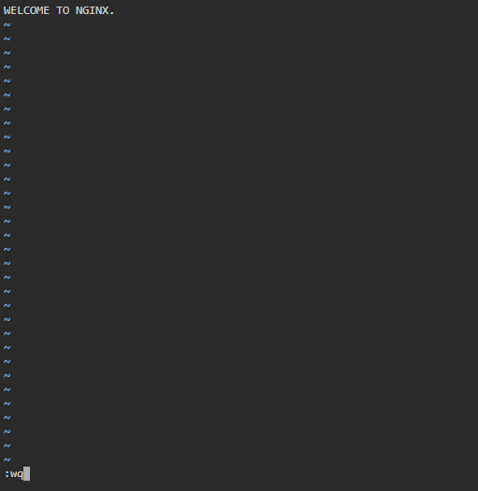

**Note:** After writing the above code in the *html* file, press **ESC** button and enter **:wq** to save the file and exit the editor.

**Step 2**: Execute the file

* Execute the Dockerfile (note that there is space between **build** and **.**)

*sudo docker build .*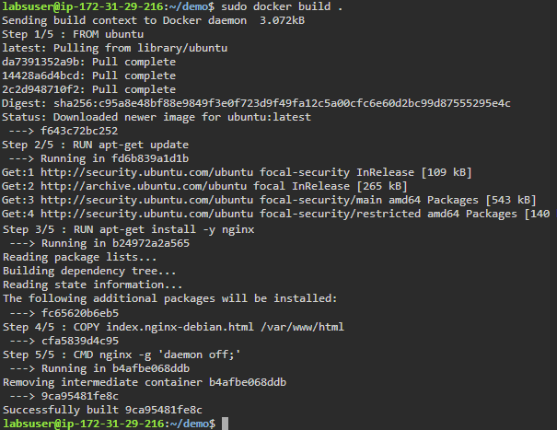

* List the images to check the newly created Docker image

*sudo* *docker images*

